**Objective Questions**

1. **List the different dtypes of columns in table “ball_by_ball” (using information schema)**

* Below are the different data types in the “ball_by_ball column

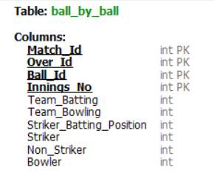

1. **What is the total number of run scored in 1st season by RCB (bonus : also include the extra runs using the extra runs table)**  
   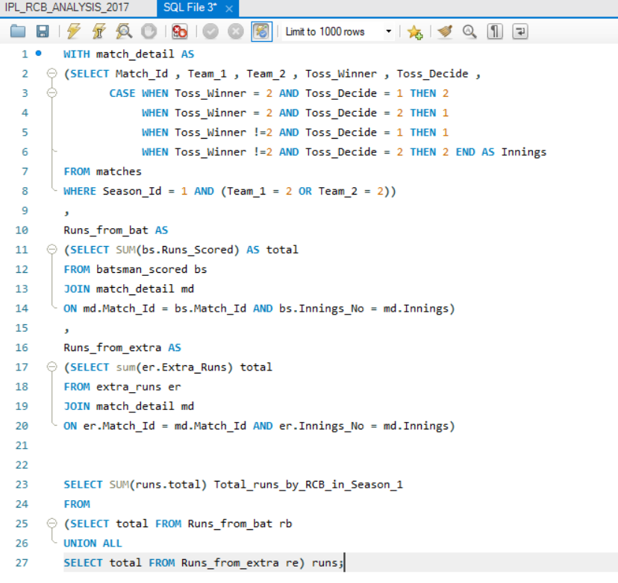

* Above query will give us the Total runs scored by RCB in Season1 : 1983

1. **How many players were more than age of 25 during season 2?**  
   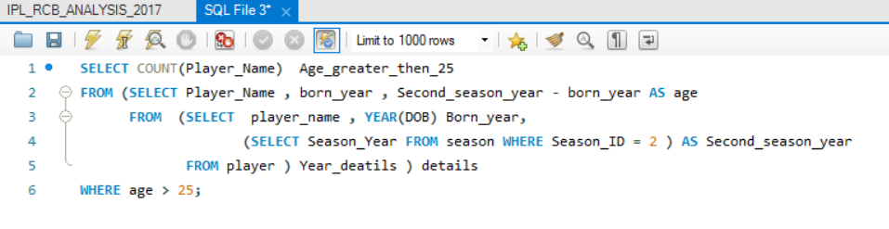

* Above query will give us the Number of players their age is greater then 25 in season 2 : 194

1. **How many matches did RCB win in season 1?**   
     
   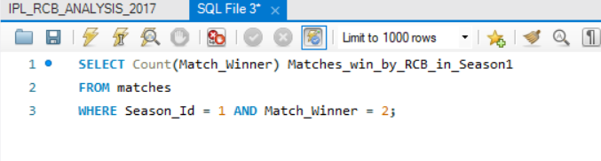

* Above query will give us the Matches win by RCB in Season1 : 4

1. **List top 10 players according to their strike rate in last 4 seasons**  
     
   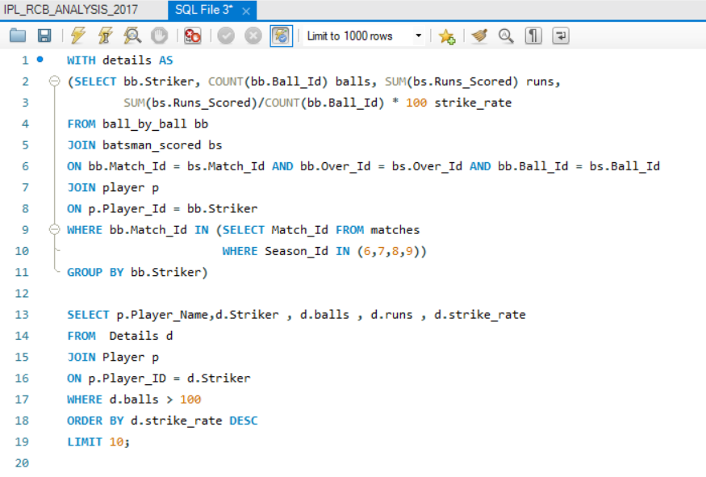

* Above query will give us the 10 players have the better strike rate in last 4 seasons
* condition given as minimum 100 balls so that tail ender’s we can skip it from the list  
  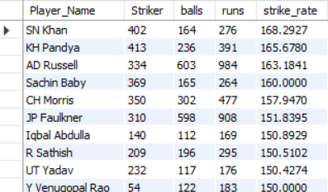

1. **What is the average runs scored by each batsman considering all the seasons?**  
   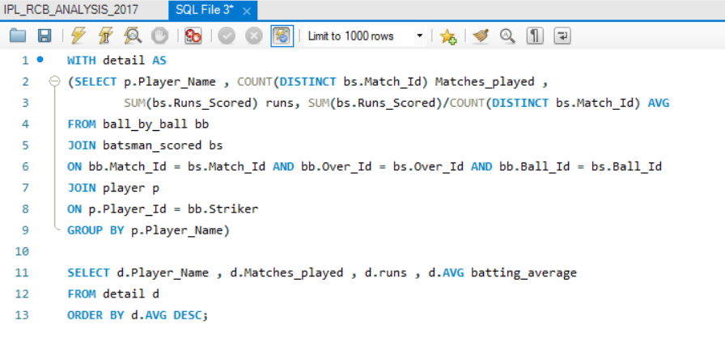

* Above query will give us : consider all seasons these are top avg runs scored by each batsmen  
  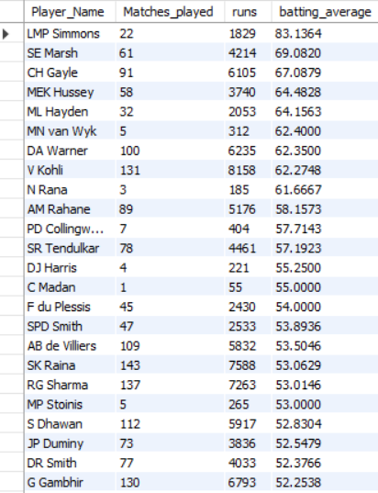

1. **What are the average wickets taken by each bowler considering all the seasons?**  
   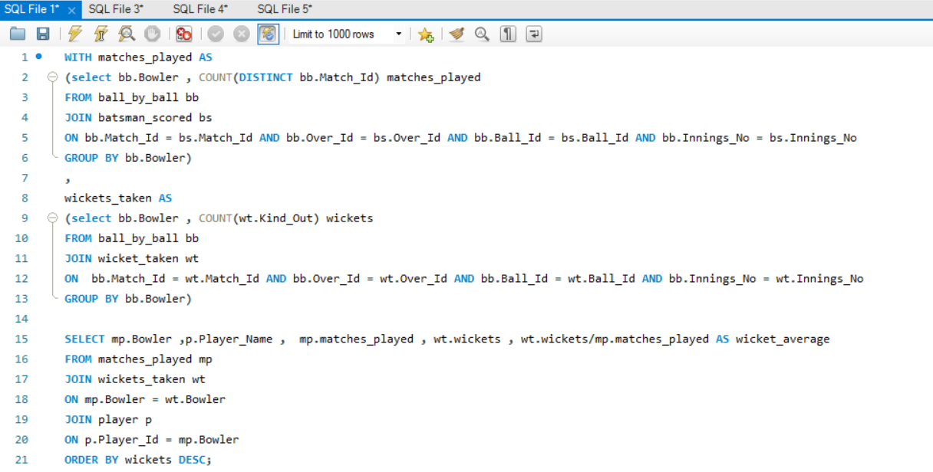

* Above query will give us : consider all seasons these are top bowler bowling avg arranged by most number of wickets   
    
  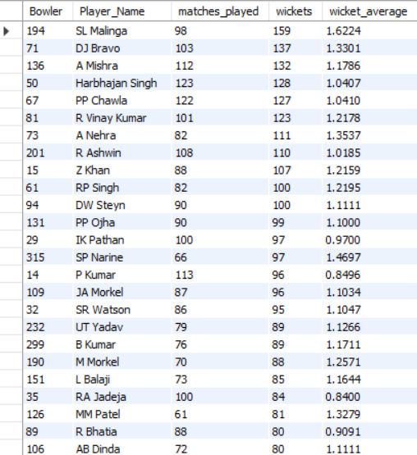

1. **List all the players who have average runs scored greater than overall average and who have taken wickets greater than overall average**  
   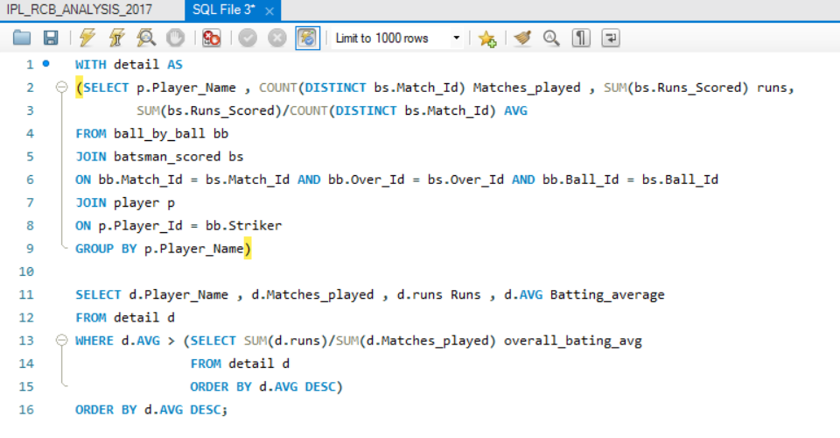

* Above query will give us the batters having the average greater then the overall batting avg  
    
  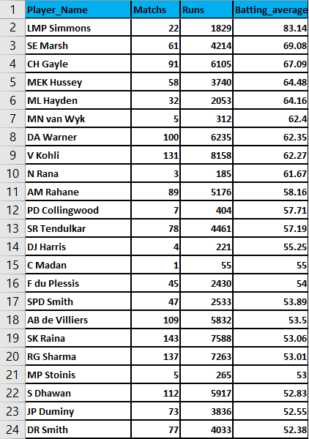  
  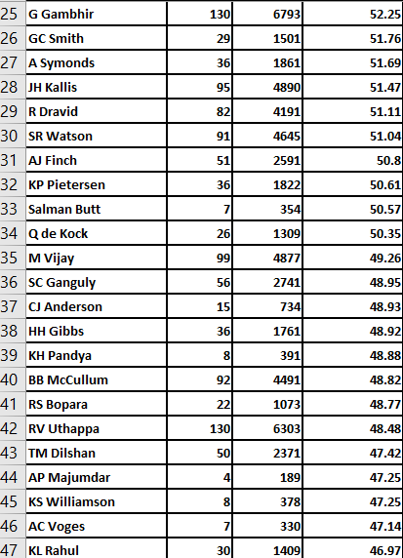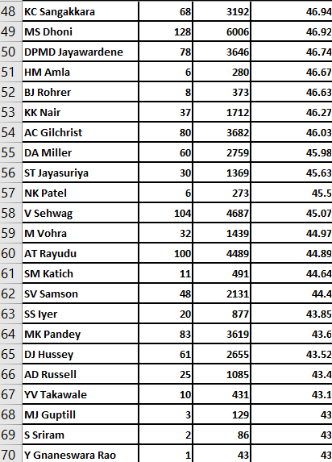  
  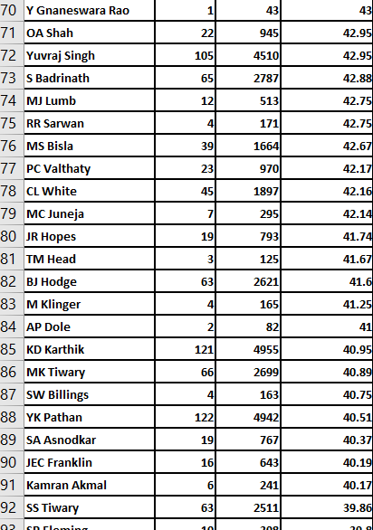  
  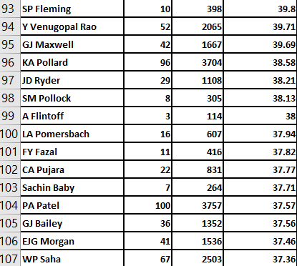  
    
  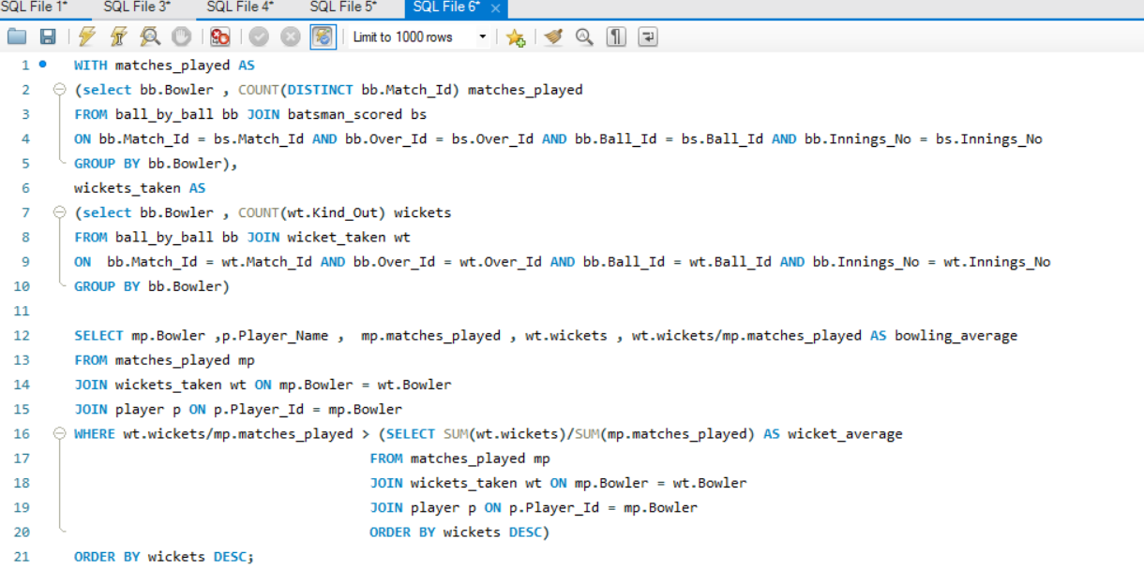
* Above query will give us the bowlers having the bowling average   
  better then the overall bowling avg

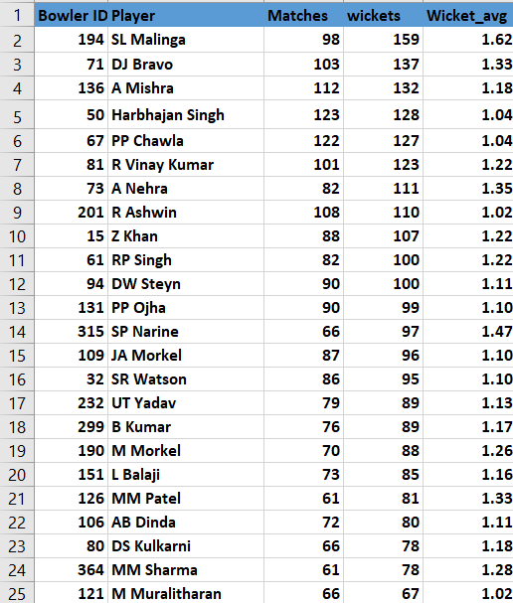  
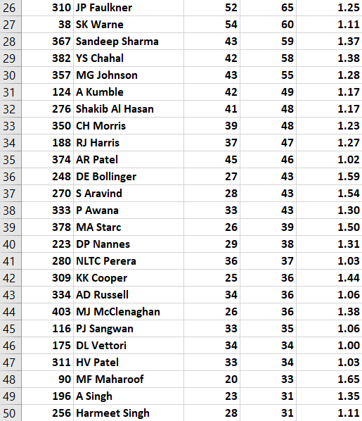  
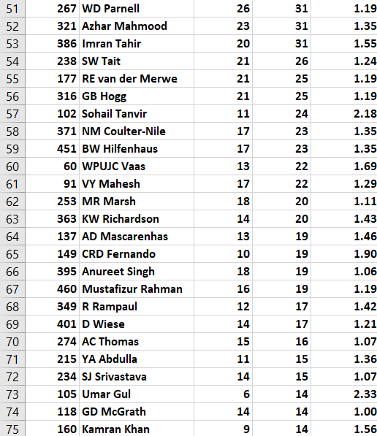  
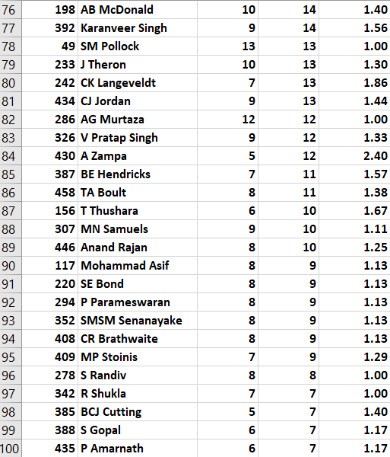  
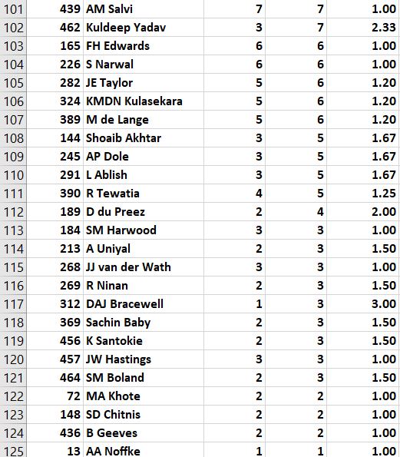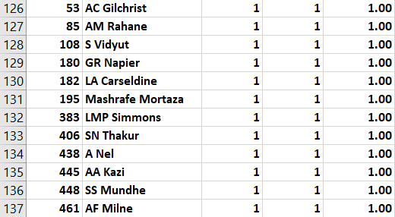

1. **Create a table rcb_record table that shows wins and losses of RCB in an individual venue.**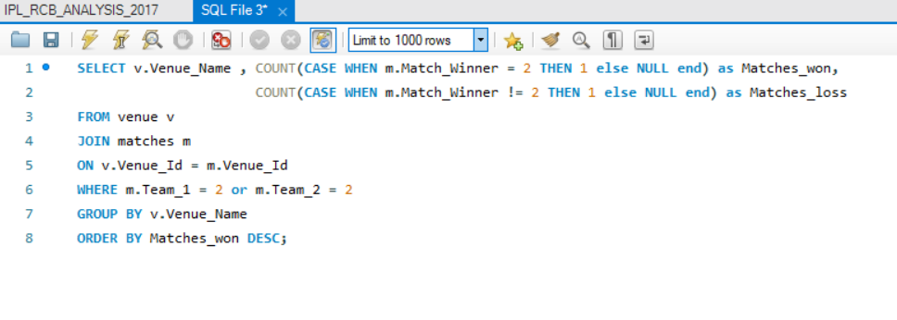

* Above query will give us the RCB overall record table by venue  
    
  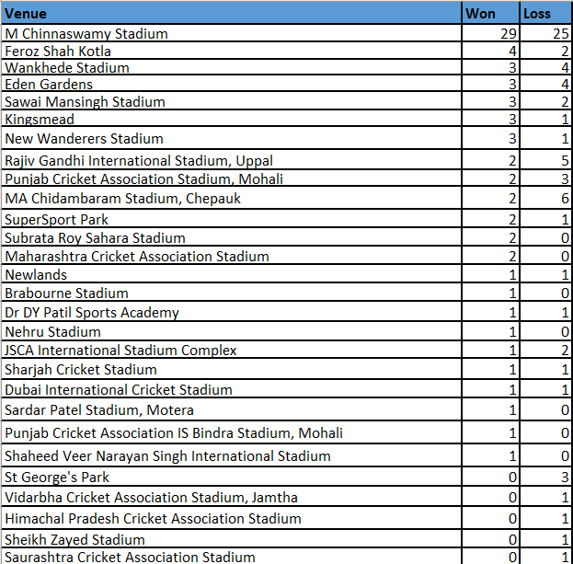

1. **What is the impact of bowling style on wickets taken.**  
   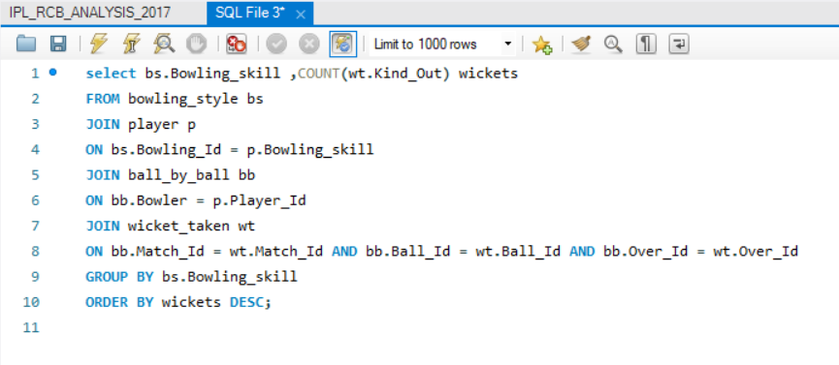

* Above query will give us the Number of wickets taken by bowling style  
    
    
  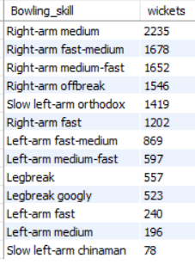

1. **Write the sql query to provide a status of whether the performance of the team better than the previous year performance on the basis of number of runs scored by the team in the season and number of wickets taken**   
     
   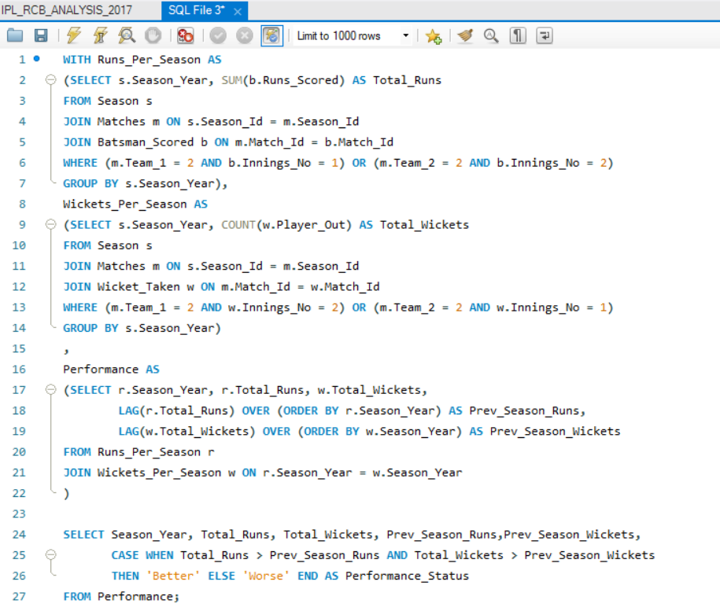

* Above query will give us the Performance status based on the total runs and total wickets in a season compared to previous season by RCB over the years  
  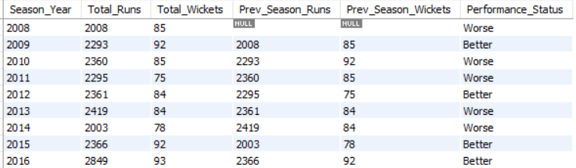

1. **Can you derive more KPIs for the team strategy if possible?**  
   Below KPI are for RCB team

* **Powerplay Performance (1-6 Overs)**RCB Team Runs in Powerplay : 6056  
  RCB Team Wickets Taken in Powerplay : 201
* **Death Overs Performance (16 – 20 Overs)**RCB Team Runs in Death Overs : 6460  
  RCB Team Wickets Taken in Death Overs : 276
* **Middle Over Performance (7-15 Overs)**   
   RCB Team Runs in Middle Overs : 9463  
   RCB Team Wickets in Middle Overs : 293
* **RCB Team Total Runs Scored - 21547**
* **RCB Team Total Wickets Taken - 770**
* **TOP 5 RUNS SCORERS IN RCB HOME**

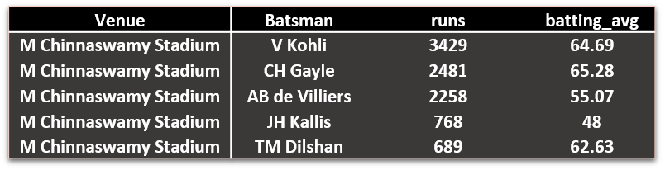

* **TOP 5 WICKET TAKERS IN RCB HOME**

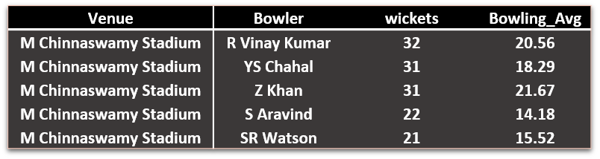

* **RCB HOME MATCHES RECORD**

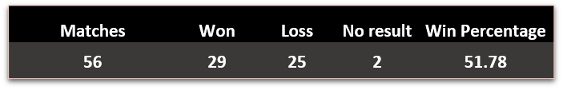

* **Most Runs**

Most runs scored for RCB by Indian player : V Kohli  
 Most runs scored for RCB by Overseas player : CH Gayle

* **Most Wickets**Most wickets taken for by Indian Player : YS chahal  
  Most wickets taken for by Overseas Player : DW Steyn

1. **Using SQL, write a query to find out average wickets taken by each bowler in each venue. Also rank the gender according to the average value.**  
   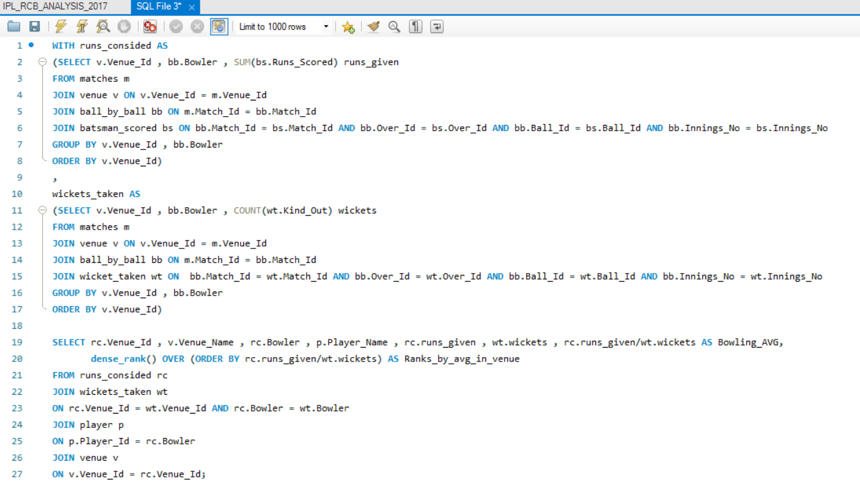

**TOP 5 WICKET TAKERS IN RCB HOME**

* Above query will give us the Bowling average calculate for each bowler in each venue and ranked as per bowing average
* Top few ranks are shown in below output images  
  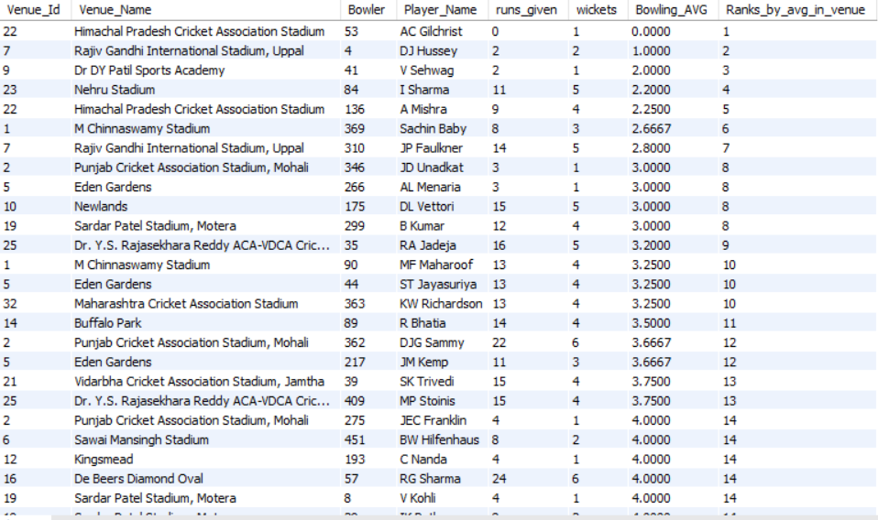  
    
  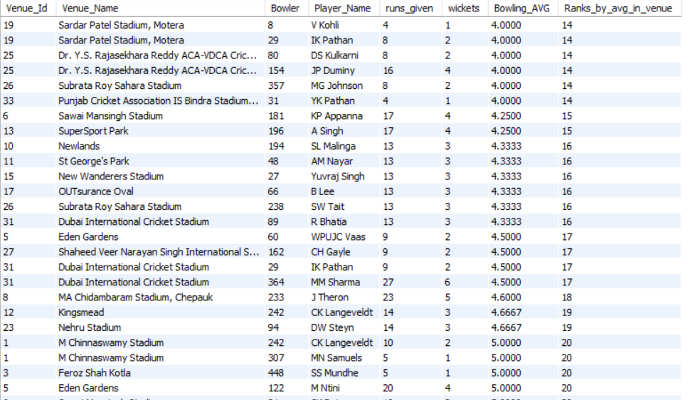  
    
    
    
  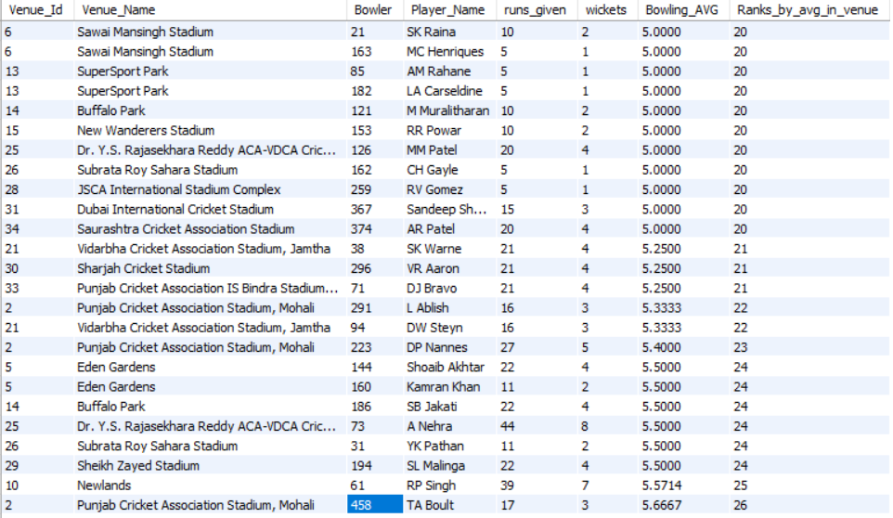

1. **Which of the given players have consistently performed well in past seasons? (will you use any visualisation to solve the problem)**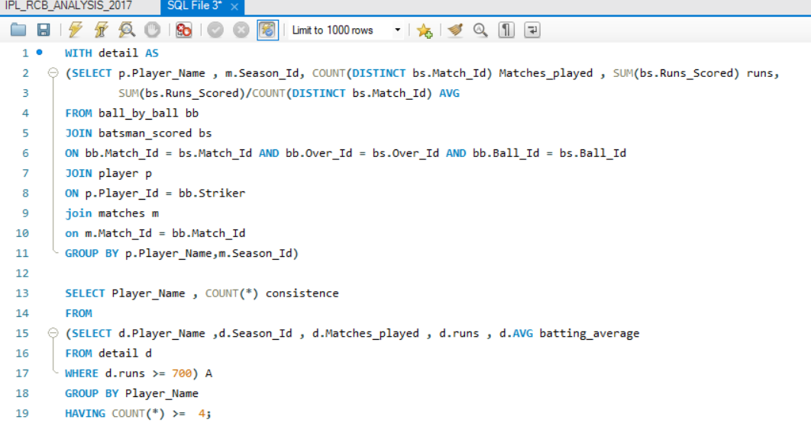

* Out of 9 seasons – 4 seasons (They scored more then 700 runs)
* Above query will give us the consistence batsmen in overall seasons of the IPL   
    
  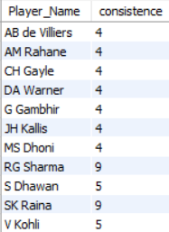  
    
    
  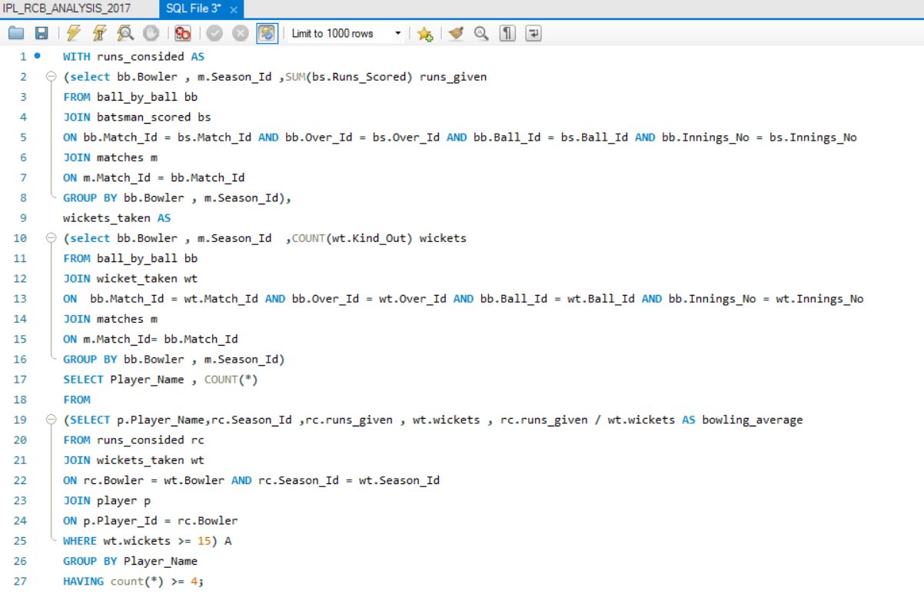
* Above query will give us consistence bowler in overall seasons of the IPL

Out of 9 seasons – 4 seasons (They took 15 wickets)  
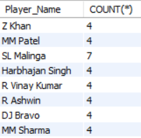

* we can take the common players in above both the list (batter and bowler ) and we can find out the All rounder’s in overall seasons of the IPL
* Out of 9 seasons – 4 seasons (They scored more then 400 runs and took 8 wickets)  
    
  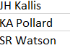

1. **Are there players whose performance is more suited to specific venues or conditions? (how would you present this using charts?)**   
     
   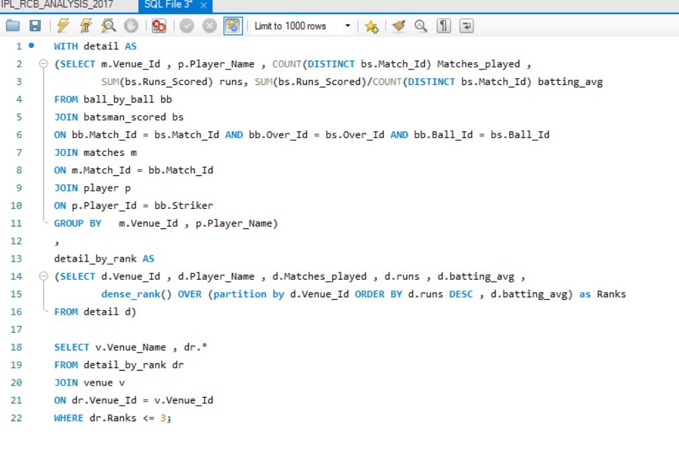

* Above query is used to find the top 3 batter in each venue 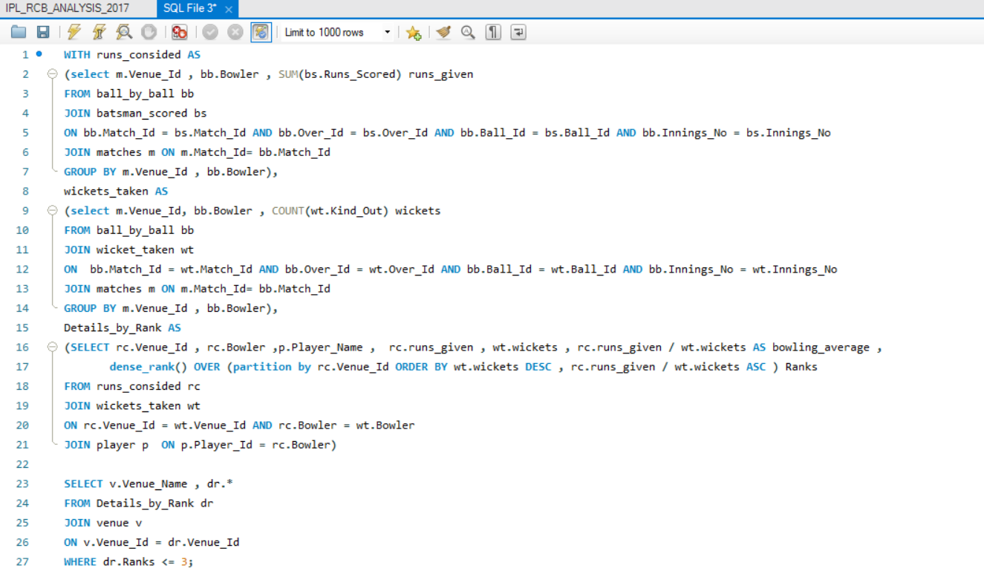
* Above query is used to find the top 3 bowlers in each venue
* Below table will show us the TOP 3 RUNS SCORESRS AND WICKET TAKERS IN EACH VENUE  
  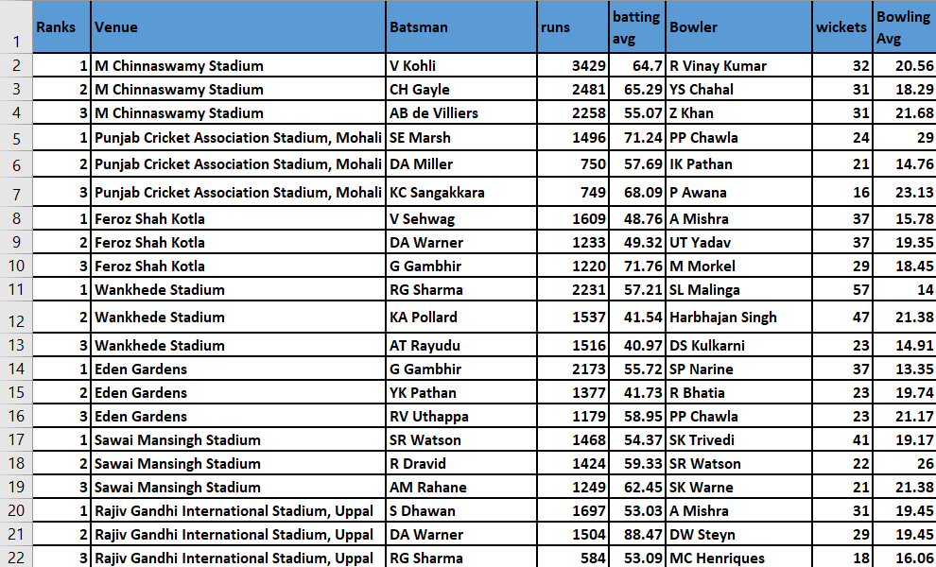  
    
  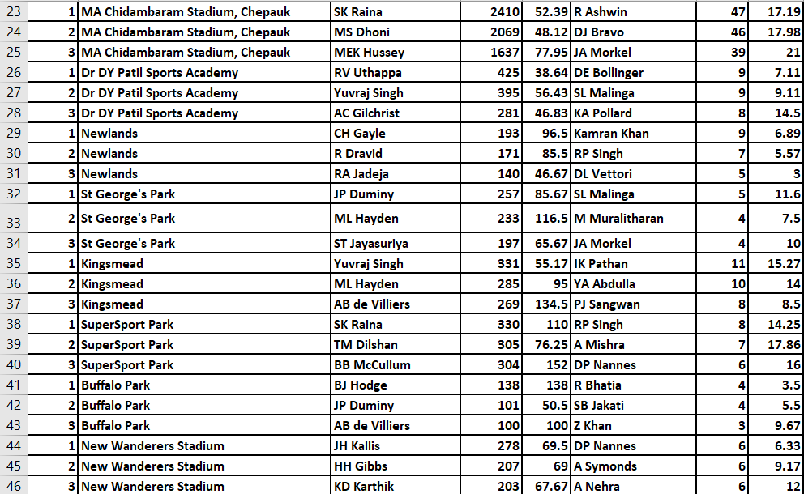  
    
  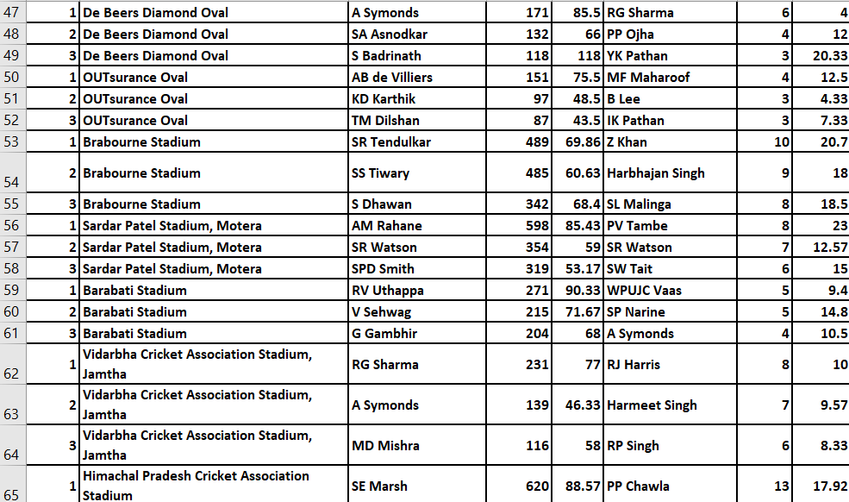  
  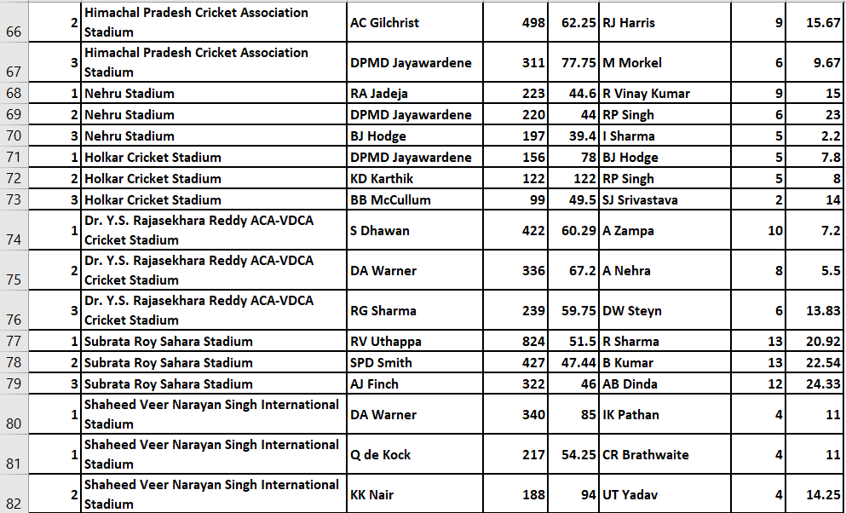  
  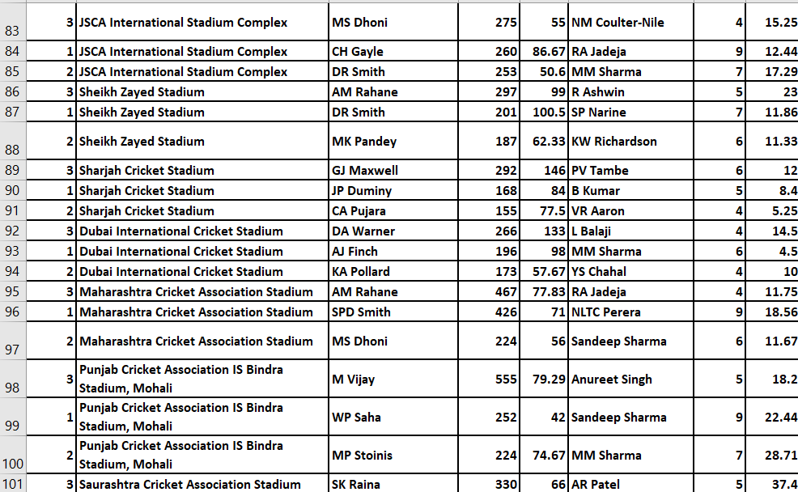  
  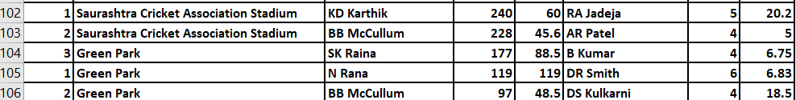

**Subjective Questions**

1. **How does toss decision have affected the result of the match ? (which visualisations could be used to better present your answer) And is the impact limited to only specific venues?**

* First calculated the total number of matches
* Then calculated Number of matches won after winning the toss
* Then based on the Venue calculated Number of matches won after winning the toss
* Finally calculated winning percentage of each venue after toss win  
    
  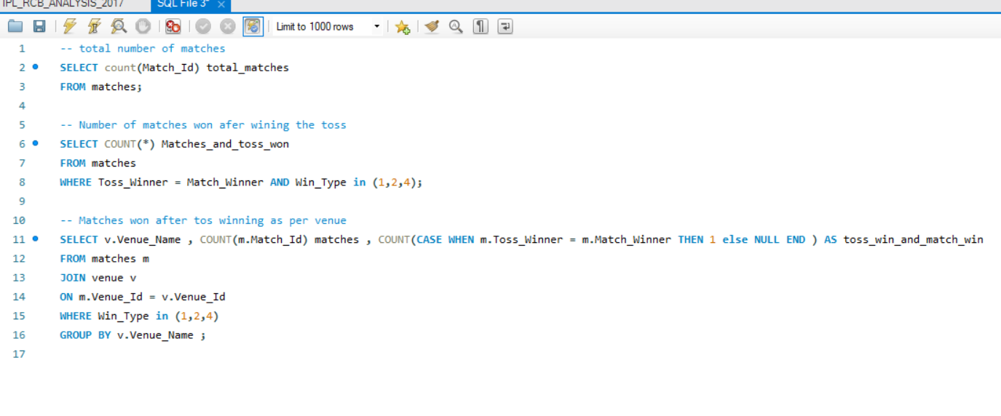

**Observation**

* Using above query we can find out
* Total Number of matches : 577
* Matches won after the toss win : 291
* Below table shows the matches won after winning the toss

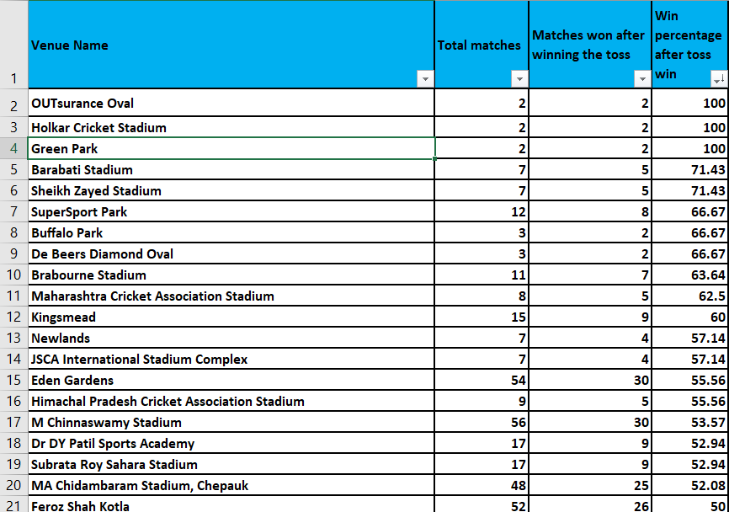  
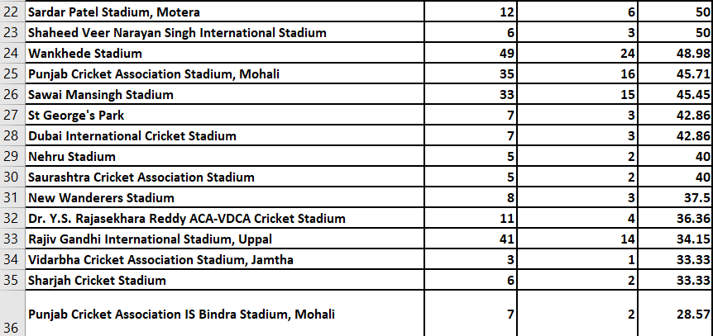

* **Recommendation** - Data represented from highest win percentage to low venue wise after winning the toss

1. **Suggest some of the players who would be best fit for the team?**  
     
   **Observation**

* Below are the retained players from last season they are fit and performance was good in last season (6 players)  
  V Kohli , TM Head , AB de Villiers , KL Rahul , YS Chahal , HV Patel
* New players need to picked from Auction  
  HH Pandya , RA Jadeja , DJ Bravo , MA Starc, Kuldeep Yadav , PJ Cummins , R Ashwin, M Vijay ,DA Miller ,V Shankar , CJ Ferguson , JP Duminy
* Batters (6)  
  V Kohli(R)(C) , TM Head (R) , AB de Villiers(R)(WK) , KL Rahul(R)(WK)(VC) , DA Miller , M Vijay
* All Rounders (5)  
  HH Pandya , RA Jadeja , DJ Bravo , JP Duminy , V Shankar
* Bowlers (7)  
  MA Starc, HV Patel(R) , YS Chahal(R) , Kuldeep Yadav , PJ Cummins , R Ashwin , CJ Ferguson  
    
  **Recommendation**  
    
  **Playing 11**
* V Kohli (R)(C)
* TM Head (R)
* AB de Villiers (R)
* KL Rahul (R)(WK)(VC)
* HH Pandya
* RA Jadeja
* DJ Bravo
* Kuldeep Yadav
* YS Chahal(R)
* HV Patel(R)
* MA Starc

1. **What are some of parameters that should be focused while selecting the players?**

* Player Performance and Form
* Fitness and Player Role
* Experience and Leadership
* Age and Consistency
* Auction Strategy and Budget remaining
* Previous Team Performance

1. **Which players offer versatility in their skills and can contribute effectively with both bat and ball? (can you visualize the data for the same)**

* Fetched the players how are scored more then 100 runs in batting
* Then Find the players taken more then 30 wickets in bowling
* From both batting and bowling list find the common players how has more then 1000 runs and 30 wickets

|  |
| --- |
| These are the players Scored more then 1000 runs and picked more then 30 wickets , so they can bat and bowl   **Observation**     * **Recommendation** - Above listed players are most versatility in their skills and can contribute effectively with both bat and ball |
|  |

1. **Are there players whose presence positively influences the morale and performance of the team? (justify your answer using visualisation)**

* calculated total matches played by each players
* Next calculated matches won by each players
* calculated the winning percentage of each players  
    
  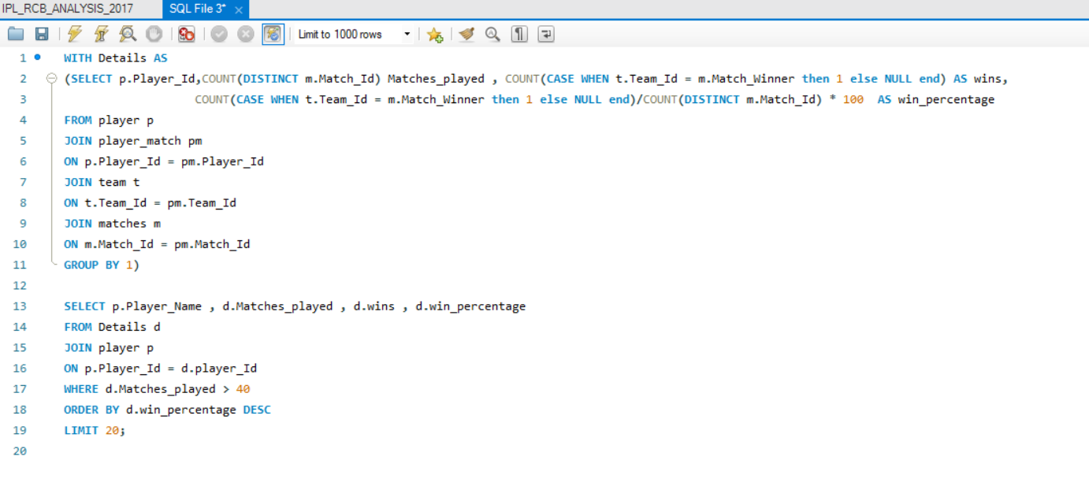
  + Above query will give us the Top 20 Players presence where team performance was well as per winning percentage

**Observation** 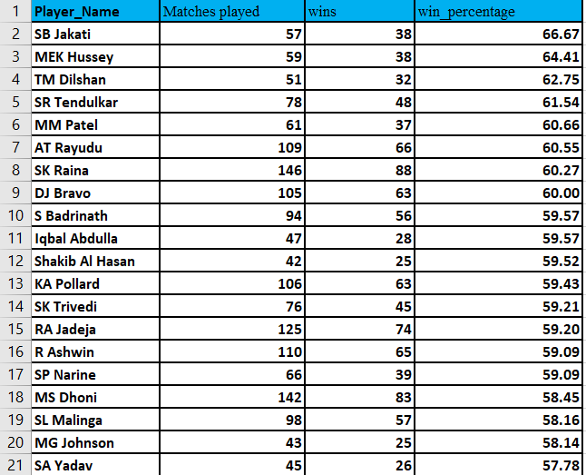

* **Recommendation** - list of players have the highest winning percentage , these players positively influences the morale and performance of the team

1. **What would you suggest to RCB before going to mega auction ?**  
   **Observation**

* Batter(6)  
  V Kohli(R)(C) , TM Head (R) , AB de Villiers(R)(WK) , KL Rahul(R)(WK)(VC) , DA Miller , M Vijay
* All Rounders (6)  
  HH Pandya , RA Jadeja , DJ Bravo , JP Duminy , V Shankar,  
  N Rana
* Bowlers (6)  
  MA Starc, HV Patel(R) , YS Chahal(R) , Kuldeep Yadav , PJ Cummins , R Ashwin

**Recommendation**

* Virat Kohli (C) - Top-order batsman and captain.
* AB de Villiers (R) - Dynamic batsman and key player.
* KL Rahul (VC) - Reliable batsman, adds stability.
* TM Head (R) - Solid middle-order batsman.
* Hardik Pandya (HH Pandya) - All-rounder, adds depth in batting and bowling.
* Ravindra Jadeja (RA Jadeja) - All-rounder, strong with both bat and ball.
* Dwayne Bravo (DJ Bravo) - Experienced all-rounder, useful in death-overs.
* Yuzvendra Chahal (YS Chahal) - Key leg-spinner for middle overs.
* MA Starc - Left-arm pacer for early breakthroughs.
* Kuldeep Yadav - Wrist-spinner for variations and middle-overs control.
* Harshal Patel (HV Patel) - Dependable pacer for both death-overs and middle overs.

Bench Options:

* Pat Cummins (PJ Cummins) - Can be a backup pacer.
* R Ashwin (R Ashwin) - Off-spinner, provides an additional spin option.
* M Vijay (M Vijay) - For additional top-order or middle-order stability.
* David Miller (DA Miller) - Can provide middle-order finishing.
* V Shankar (V Shankar) - All-rounder, adds flexibility.
* N Rana- All-rounder, adds flexibility   
  JP Duminy (JP Duminy) - All-rounder, provides additional batting depth and spin option.
* This XI balances strong batting, versatile all-rounders, and a varied bowling attack, providing a well-rounded team for different match situations.
* Below are the retained players from last season they are fit and performance was good in last season (6 players)
* V Kohli , TM Head , AB de Villiers , KL Rahul , YS Chahal , HV Patel
* New players need to picked from Auction  
  HH Pandya , RA Jadeja , DJ Bravo , MA Starc, Kuldeep Yadav , PJ Cummins , R Ashwin, M Vijay ,DA Miller ,V Shankar , N Rana, JP Duminy

**7. What do you think could be the factors contributing to the high-scoring matches and the impact on viewership and team strategies**

**Factors contributing to the high-scoring matches**

* + **Flat Pitches:** Pitches with little assistance for bowlers, making it easier for batsmen to score runs.
  + **Small Boundaries:** Smaller ground dimensions lead to more boundaries and higher scores.
  + **Power Hitting:** Modern batsmen are trained to hit big shots, with many specializing in aggressive batting.
  + **Fielding Restrictions:** Powerplay rules limit the number of fielders outside the circle, making it easier to score runs.
  + **Free Hits:** The penalty for overstepping (no-ball) offers a free hit, encouraging batsmen to take risks.
  + **Enhanced Fitness:** Players are fitter, allowing them to play longer and more aggressively.
  + **Specialized Training:** Focused training on T20 skills, such as death over hitting and yorker bowling.
  + **Impact on Viewership**
  + **Exciting Matches:** High-scoring games are often more thrilling and attract more viewers.
  + **More Boundaries and Sixes:** Fans enjoy watching big hits and high run rates.
  + **Social Media Buzz:** High-scoring matches generate more discussion and excitement on social media platforms.
  + **Fan Involvement:** Spectators are more likely to stay engaged throughout high-scoring games.
  + **More Viewership:** Higher viewership numbers lead to increased advertising revenue for broadcasters.
  + **Prime Time Matches:** High-scoring games often attract prime time slots, further boosting revenue.

**Impact on Team Strategies**

* **Batting Strategies**
* **Aggressive Starts:** Teams prioritize a strong start, often sending aggressive openers to maximize powerplay overs.
* Depth in Batting: Teams prefer a longer batting lineup to sustain aggressive batting throughout the innings.
* **Bowling Strategies**
* **Specialized Death Bowlers:** Emphasis on having bowlers who can execute Yorkers and slower balls effectively in the final overs
* **Spin Variations**: Use of spinners who can bowl economically and take

wickets during the middle overs.  
  
  
**8. Analyze the impact of home ground advantage on team performance and identify strategies to maximize this advantage for RCB.**

* calculated total number of matches played by RCB in Home and Away
* After that calculated matches won in home in away ground
* finally calculated the winning percentage in Home and Away  
    
  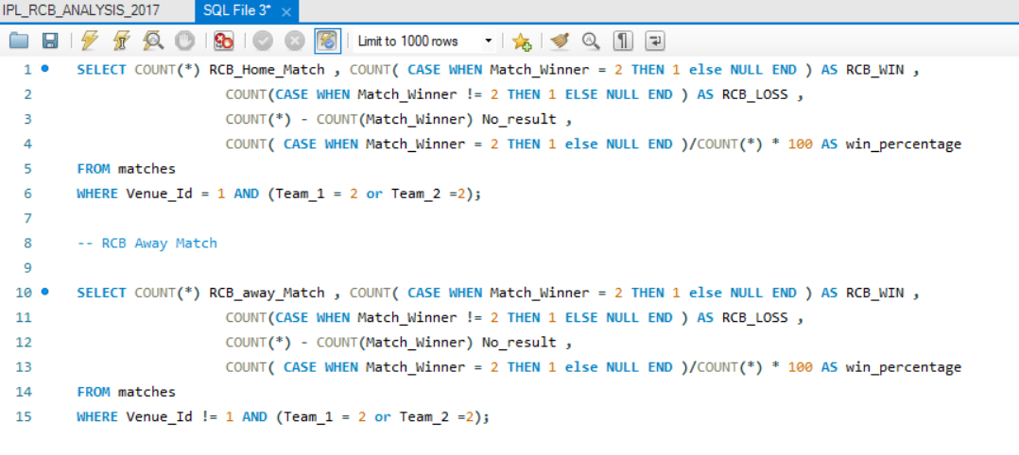  
    
  **Observation**  
  **Home Record**  
    
    
  **Away Record**  
    
  **Recommendation**
* RCB performs slightly better at home compared to away games, with a win percentage difference of 2.39%.
* Prepare pitches that favor RCB's strengths (e.g., spin or pace).
* Increase fan support with promotions and community events to boost home advantage.
* Schedule regular practice sessions at the home ground to familiarize players with conditions.
* Use a lively and high-attendance crowd to put pressure on opponents.
* Arrange key matches at home, especially against strong teams.
* Leverage insights from local coaches and former players familiar with home ground conditions.
* Adapt training sessions to simulate home ground conditions and challenges.
* Continuously analyze home performance data to refine strategies.
* Ensure players are well-rested before home matches to optimize performance.
* Develop specific tactics for home games based on data and previous   
  performance.

**9. Come up with a visual and analytical analysis with the RCB past seasons performance   
and potential reasons for them not winning a trophy.**

* Based on the season wise calculated the total matches played
* As per season matches won , loss
* calculated win percentage as per the season wise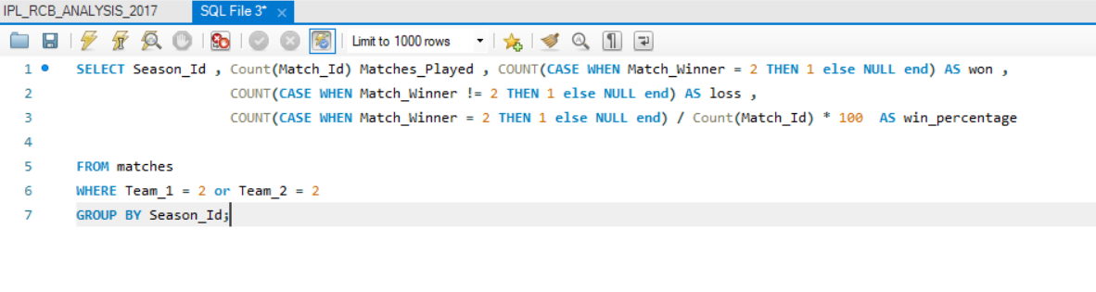
* Above query will give us the Matches WIN/LOSS record by RCB sesson wise  
  **Observation**  
    
  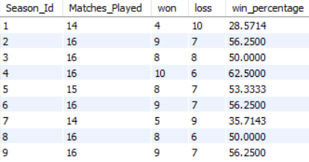
* overall calculated total matches played by RCB and win , loss and win percentage   
  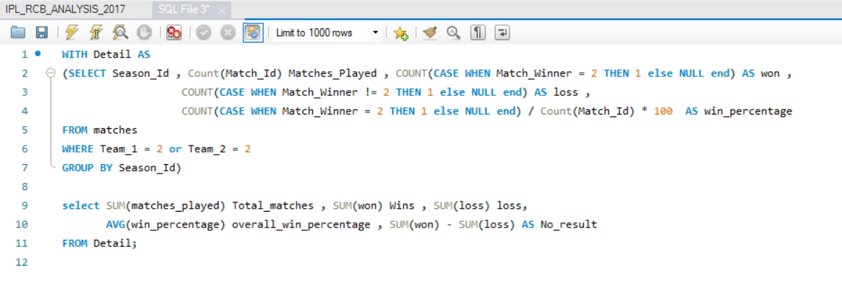
* Above query will give us Total Match Record  
    
  
* **calculated total runs scored and total wickets taken by RCB in season wise**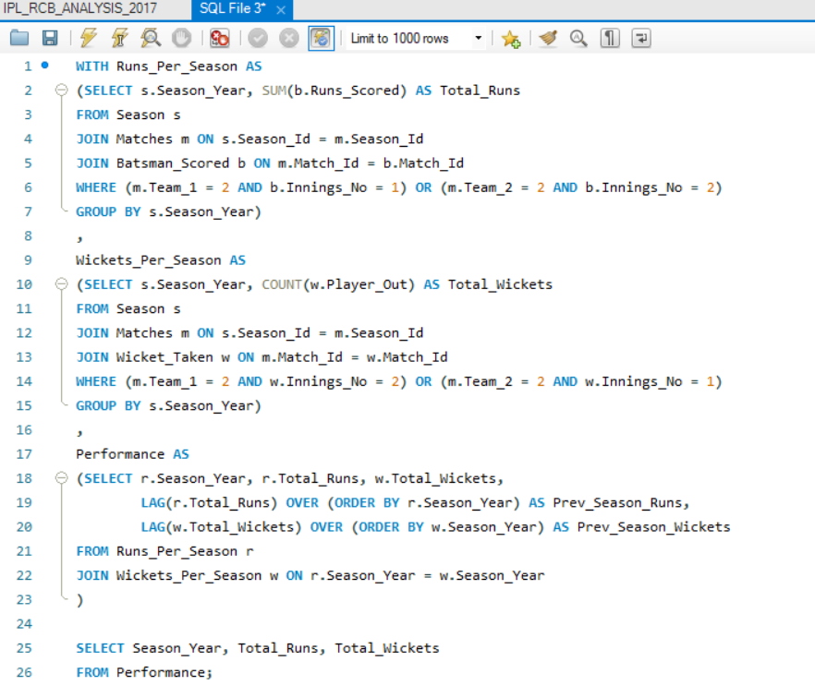
* Above query will give us RUNS/WICKETS sesson wise  
  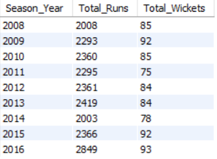  
  **Recommendation**
* RCB's inconsistent performance over the seasons, frequent team and management changes, and reliance on key players in crucial matches have hindered their success.
* Injuries to critical players at pivotal moments and questionable strategic decisions have further impacted their chances of winning a trophy.
* Strengthening the supporting cast, ensuring stability, and improving pressure handling could enhance future performance.   
  Enhanced injury management and strategic planning are also essential. Focusing on these areas may help RCB break their title drought.

**10. How would you approach this problem, if the objective and subjective questions weren't given?**

* **Analyze the Data :** Look at each table to see how they relate to each other. For example, how matches relate to teams, how players relate to their performances, etc.
* **Find RCB Stats :** Look at RCB’s batting and bowling performance, how well they do in home games versus away games, and overall win/loss records.
* **Analyze Player Performance :** Review the performance data of all RCB players to see who has been consistently good. This will help in deciding which players to retain.
* **Decide on Retained Player :** Based on the performance analysis, select the players who should be retained. These are the players who have shown good performance and are valuable to the team.
* **Plan for Auction :** Look at the performance stats of all available players in the auction. Choose players who can fill the gaps in the team and strengthen the overall performance.

1. **In the "Match" table, some entries in the "Opponent_Team" column are incorrectly spelled as "Delhi_Capitals" instead of "Delhi_Daredevils". Write an SQL query to replace all occurrences of "Delhi_Capitals" with "Delhi_Daredevils".**

* There is not match table and Opponent team column in the given data base
* As per my assumption if there is a scenario as per question above   
  I would have changed like this  
    
  UPDATE Match   
  SET Opponent_Team = 'Delhi_Daredevils'  
  WHERE Opponent_Team = 'Delhi_Capitals';